Forward Biased Diode
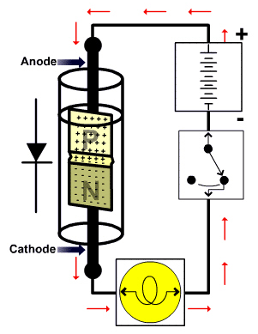
- Allows current flow across the P-N junction during circuit operation
- Anode connected to positive side of circuit
- Cathode connected to negative side of circuit

